## Exp. 2

## Design a LED Chaser

Circuit Diagram:

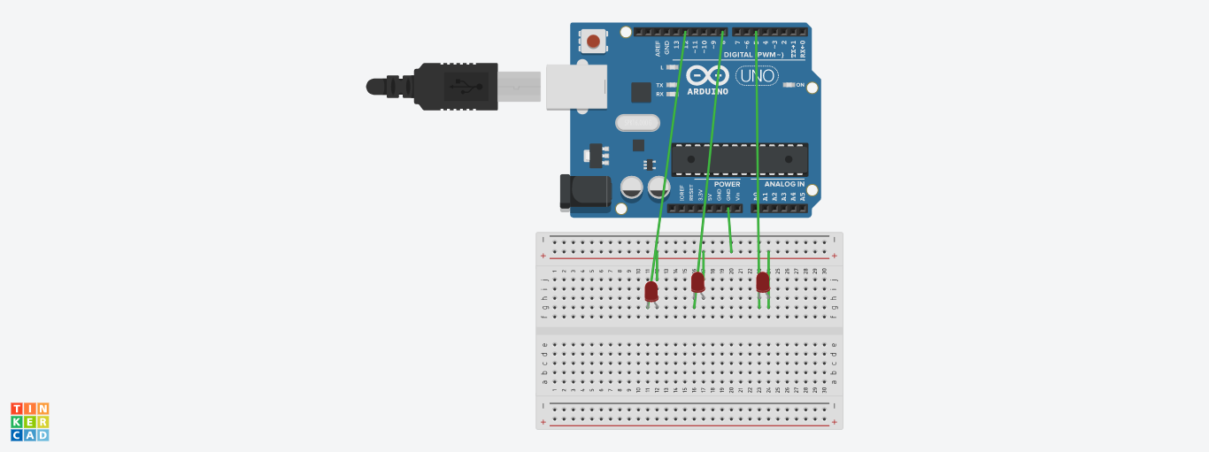

Theory

Concept Used: In led chaser, the LEDs lights one by one for a period of 1second and the cycle repeats giving the running light appearance.

Learning & Observations:

The LED light glow one by one as shown like one chasing other.

Problems & Troubleshooting:

1. Problem in fixing wire from bread board to Arduino uno.
2. Problem while writing code for the doing Arduino uno programming.

Precautions:

1. Correct connection of negative and positive terminal of led.
2. Don’t put Arduino uno near water.
3. Check the USB port of computer is working.
4. Check the Arduino uno software and select the correct port (in which Arduino uno is connected).

Learning Outcome:

1. LED light glow in the sequence of 12,8,5.
2. Arduino function as a controller in led chaser.
3. Bread board is used to organize the circuit.